Seminar Report
ON
Analog Communication System


Under Guidance of: Submitted By:
Ms. Jyoti Bala Natasha
Assistant Professor Bachelor of Computer Applications Department of Computer Applications College Roll No. 245062

Maharaja Agrasen Institute of Management and Technology
(Affiliated to Kurukshetra University, Kurukshetra & Approved by AICTE)
Old Saharanpur Road, Near Agrasen Chowk, Jagadhri-135003 (Haryana)

DECLARATION
I hereby declare that the seminar report titled “Analog Communication System” is an authentic work carried out by me under the guidance of Ms. Jyoti Bala. This report has not been submitted for any other seminar, project, or academic requirement in any institution. All the information and data provided in this report are sourced from credible references, and proper citations have been given wherever applicable.
I take full responsibility for the content and accuracy of the work presented in this report.

Date: Signature of the Candidate

ACKNOWLEDGEMENT
I would want to convey my heartfelt gratitude to Ms. Jyoti Bala, my mentor, for her invaluable advice and assistance in completing my project. She was there to assist me every step of the way, and her motivation is what enabled me to accomplish my task effectively. I would also like to thank all of the other supporting personnel who assisted me by supplying the equipment that was essential and vital, without which I would not have been able to perform efficiently on this project.
I’d also like to thank my friends and parents for their support and encouragement as I worked on this assignment.

Natasha

ABSTRACT
An analog communication system transmits information by encoding it onto a continuous waveform, known as an analog signal, where the signal amplitude varies proportionally to the information being conveyed, allowing for the transmission of real-world phenomena like voice or video without discrete quantization, but susceptible to noise and interference due to its continuous nature.

TABLE OF CONTENTS
Declaration ii
Acknowledgement iii
Abstract iv
- Introduction to Analog Communication System 1
- 2
  - 2
  - 3
  - 4
  - 5
- 6
- 8
- 10
- 15
- Advantages 26
- Disadvantages 31
- Conclusion 36
- References 37

- Introduction to Blockchain Technology

Blockchain technology is a decentralized, distributed ledger system that allows data to be securely stored and shared across multiple computers or "nodes." The primary feature of blockchain is its ability to ensure that once data is recordd, it cannot be altered or deleted easily. This makes it a powerful tool for ensuring transparency, security, and integrity in digital transactions and data management.
At its core, blockchain works by organizing transactions into blocks. Each block contains a list of transactions, and once a block is full, it is added to a chain of previously recorded blocks, hence the name "blockchain." The blocks are linked together in chronological order through cryptographic hashes, which are unique codes generated from the data in the block. These hashes ensure that even the slightest change to a block would alter its hash, making tampering with the data easily detectable.
What sets blockchain apart from traditional centralized systems is its decentralized nature. In traditional systems, a central authority (like a bank or a government) manages the data, making it susceptible to single points of failure or manipulation. In contrast, blockchain relies on a network of nodes (computers) that validate and store data independently. This makes the system more resilient and reduces the risk of fraud or corruption, as there is no central entity to control the system.



- Types of Blockchain Technology

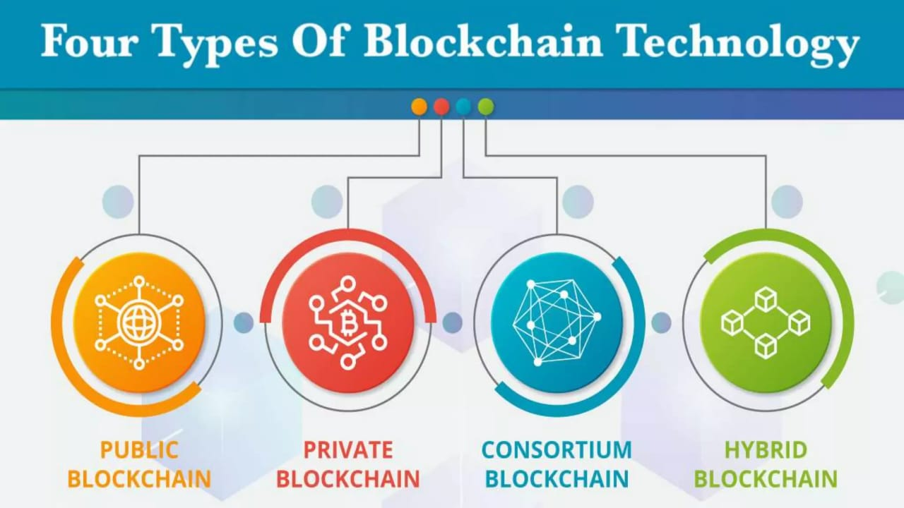
- Public Blockchain
A public blockchain is a type of blockchain that is open and accessible to anyone who wants to participate. Unlike private or permissioned blockchains, where access and control are restricted to a specific group of participants, public blockchains are decentralized and allow anyone to join, validate transactions, and even propose new blocks to be added to the blockchain.
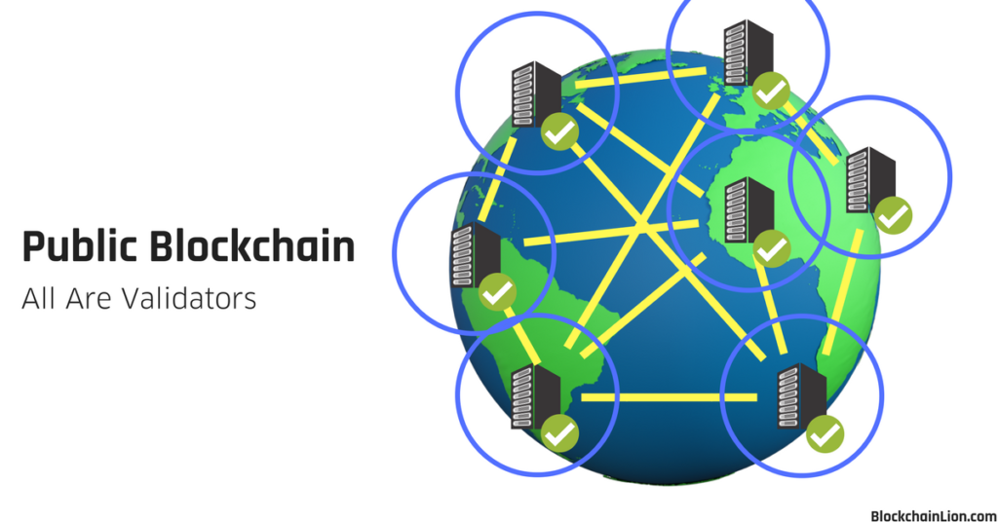
- Private Blockchain
A private blockchain is a type of blockchain where access is restricted to a specific group of participants, and the network is controlled by a central entity or a group of trusted entities. Unlike public blockchains, which are open and permissionless, private blockchains are permissioned, meaning that only authorized individuals or organizations can participate in the network, validate transactions, and add new blocks.
In a private blockchain, the central authority or consortium of participants governs who can join the network and what permissions they have. This centralized aspect gives the network more control over aspects like privacy, data access, and who can participate in consensus activities. Private blockchains can be used by companies, governments, or other entities that need a more controlled environment for managing their data or transactions.
private blockchains offer the advantages of speed, scalability, and privacy, making them suitable for enterprise use cases where access control, confidentiality, and efficiency are critical. However, they come with the trade-off of reduced decentralization and transparency compared to public blockchains.

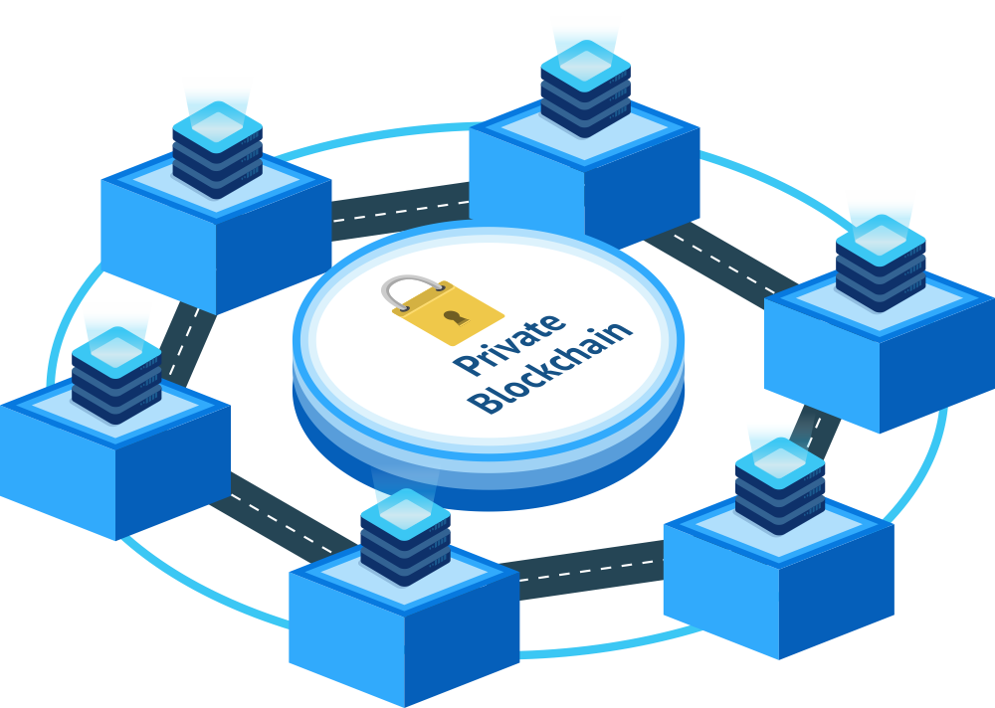
- Consortium Blockchain

A consortium blockchain is a type of blockchain that is controlled and operated by a group of organizations, rather than a single entity. It is a hybrid between public and private blockchains, combining aspects of both. In a consortium blockchain, multiple trusted entities share the responsibility of maintaining the network, validating transactions, and managing consensus mechanisms.

a consortium blockchain combines the benefits of decentralized collaboration with the efficiency and privacy that organizations need in specific industries. It provides an ideal middle ground for organizations that require a controlled environment but still want to benefit from the transparency and security that blockchain technology offers.

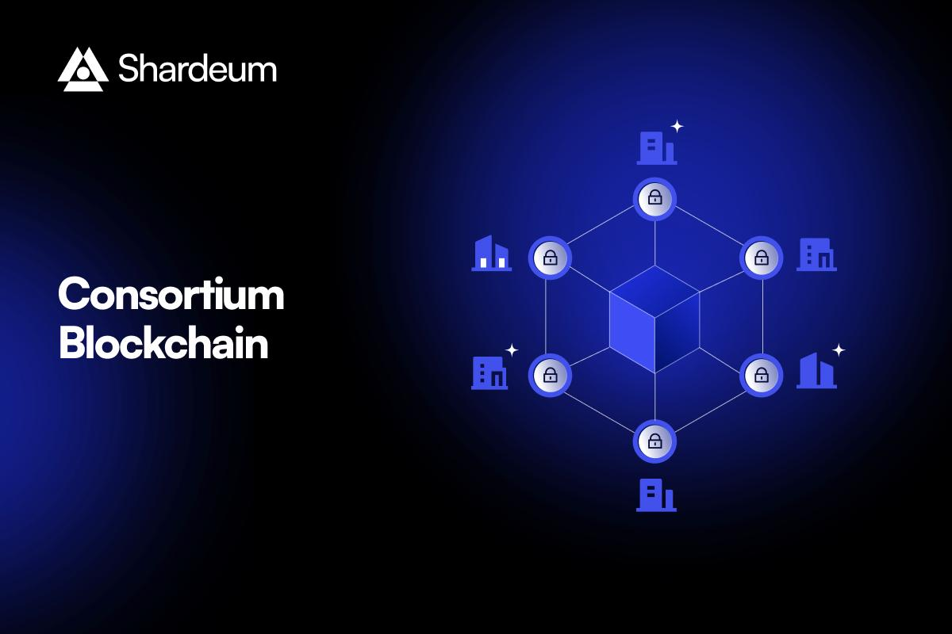

- Hybrid Blockchain
A hybrid blockchain is a combination of both public and private blockchains, designed to provide the best of both worlds. It allows for a balance between the openness and decentralization of public blockchains and the privacy and control of private blockchains. Hybrid blockchains are often used by organizations that need both public transparency and private control over certain aspects of their network.

a hybrid blockchain offers a flexible and efficient solution for organizations that want to combine the transparency of public blockchains with the control and privacy of private blockchains. This makes it ideal for industries where sensitive data needs to be protected while still allowing for certain aspects of the blockchain to be publicly verifiable.

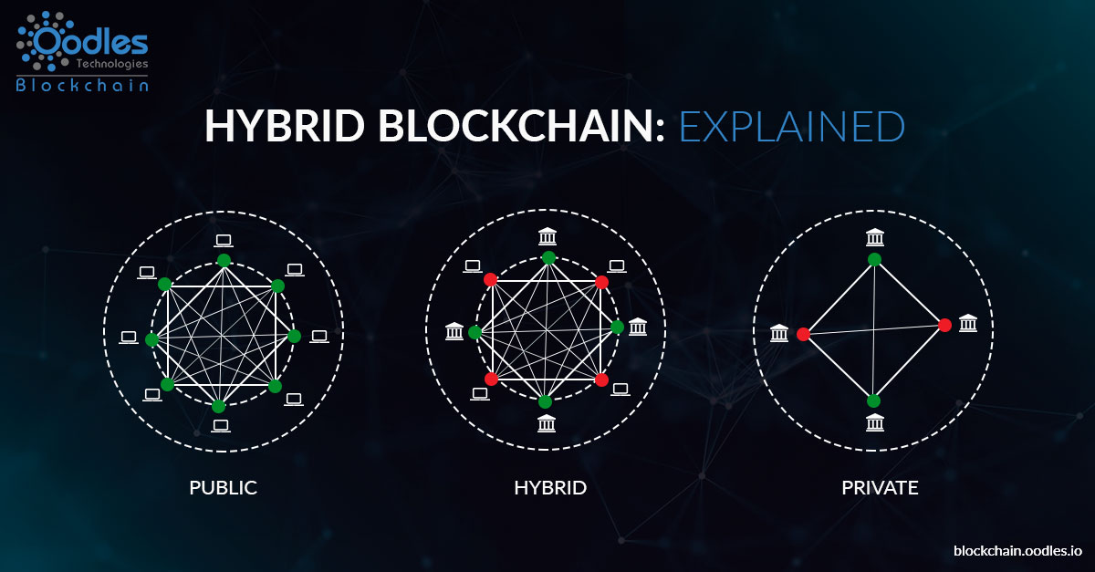

- Why is Blockchain Technology important?

Blockchain technology is important for several reasons, primarily due to its ability to address fundamental issues of trust, transparency, and security in digital interactions. Below are some of the key reasons why blockchain is becoming a transformative technology:

- Transparency and Immutability
Transactions recorded on a blockchain are visible to all participants in the network (especially in public blockchains). This level of transparency promotes accountability and reduces fraud. Additionally, once data is added to the blockchain, it becomes immutable, meaning it cannot be altered or deleted without the consensus of the network. This ensures the integrity of the data, making it nearly impossible to tamper with past records, which is especially important for industries like finance, healthcare, and supply chain management.
- Security
Blockchain uses cryptographic techniques to secure data and transactions. Each block in the blockchain is linked to the previous block through a unique cryptographic hash. This makes it difficult for anyone to tamper with data once it has been recorded. The distributed nature of the blockchain means that even if one or more nodes in the network are compromised, the overall system remains secure because there are many copies of the data spread across different locations. This high level of security is crucial in industries like banking, healthcare, and government.
- Reduced Costs
Blockchain can significantly reduce costs by eliminating the need for intermediaries (such as banks or payment processors) and reducing the overhead associated with verification, reconciliation, and compliance. For example, in cross-border payments, blockchain allows for direct transactions between parties, bypassing traditional banking intermediaries, which reduces transaction fees and processing times.
- Disintermediation and Reduced Risk of Fraud
Since blockchain removes intermediaries and enables direct peer-to-peer interactions, it helps to reduce the risks of fraud that are often associated with central authorities. Fraudulent activities such as double-spending, data manipulation, and misreporting are significantly harder to carry out due to the transparent and immutable nature of blockchain records.

Supply Chain and Provenance Tracking
Blockchain can improve transparency and traceability in supply chains. By recording every step of the journey of a product (from raw materials to the final product) on the blockchain, businesses can ensure the integrity and authenticity of goods. This has applications in industries like food, luxury goods, and pharmaceuticals, where consumers and businesses alike demand more information about the origins and handling of products.

Innovation and New Business Models
Blockchain has opened up opportunities for new business models and innovations, such as tokenization of assets (like real estate, stocks, or art) and the rise of decentralized finance (Defi) platforms that allow users to access financial services without intermediaries. These innovations are driving a new wave of entrepreneurship and creating new industries
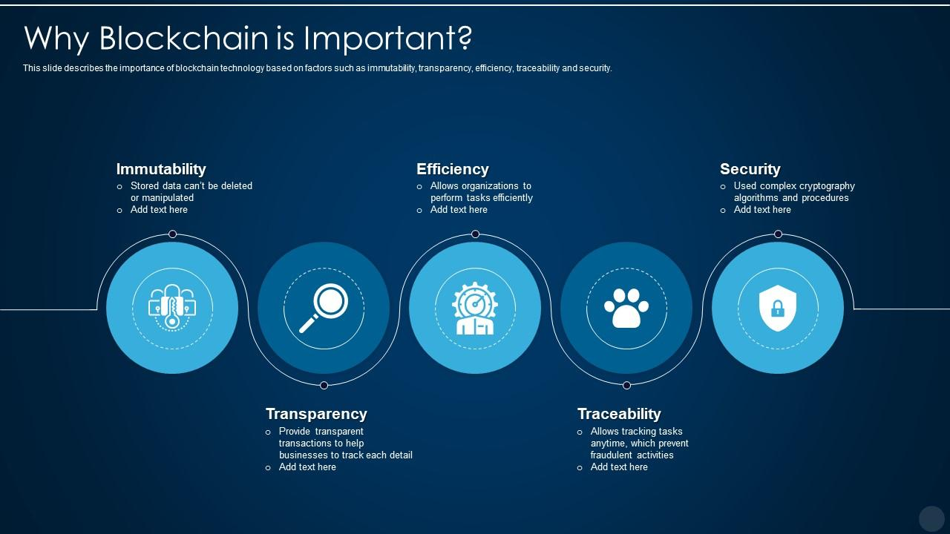
- How does Blockchain Technology works?

- Initiating a Transaction:

One user (say, Alice) wants to send a transaction to another user (Bob). This transaction could be a transfer of cryptocurrency, a smart contract execution, or another type of data.
Alice creates a transaction and broadcasts it to the blockchain network.

- Validation by Network Participants (Nodes):
The transaction is sent to the network of nodes (computers) that participate in the blockchain. These nodes are distributed across the world and each node has a copy of the blockchain.
Nodes validate the transaction to ensure that it is legitimate. For example, in the case of cryptocurrency, nodes will check that Alice has enough funds to make the transfer and that the transaction follows the rules of the blockchain.

- Consensus Mechanism:
After validation, the transaction needs to be added to the blockchain. The network of nodes uses a consensus mechanism to agree on which transactions should be added to the next block in the chain.

- Adding the Block to the Blockchain:
Once a consensus is reached, the transaction is grouped together with others into a new block.
The new block is added to the blockchain, linking it to the previous block using its hash. This creates an immutable record, because if someone tried to alter a block in the chain, the hash would change, which would disrupt the entire chain, making tampering detectable.
- Transaction Completion:
The transaction is now considered complete, and the updated blockchain (with the new block) is shared with all the participants in the network. Each participant updates their own copy of the blockchain with the new block.
For example, Alice’s transaction is now visible on the blockchain and Bob has received the funds (or data) that Alice sent.

Conclusion
In essence, blockchain technology works by utilizing a decentralized network of nodes to validate and store transactions in an immutable and secure manner. Transactions are grouped into blocks, which are then linked together in a chain, ensuring transparency, trust, and security. With its decentralized nature, cryptographic security, and consensus mechanisms, blockchain provides a reliable way to transfer and store data without the need for centralized control or intermediaries.

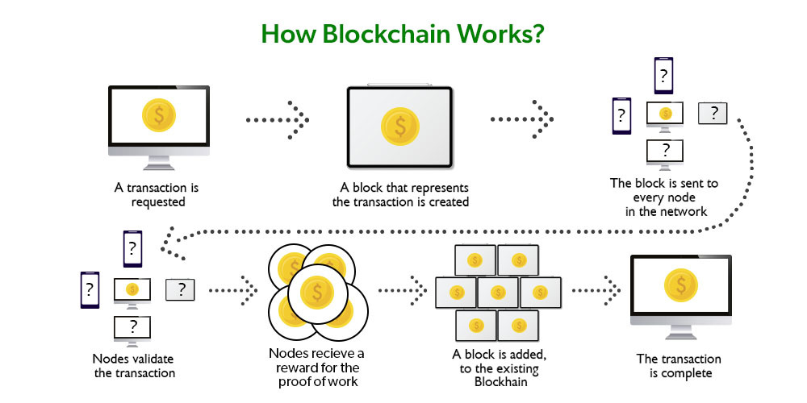

- Transaction process of Blockchain Technology
The transaction process in blockchain technology involves several key steps, ensuring the security, transparency, and immutability of the transaction. Below is a detailed breakdown of how the transaction process works from initiation to final confirmation:

1. Transaction Creation
- Initiation: A user (let’s call them Alice) creates a transaction. This transaction contains the details such as:
  - The amount being transferred (e.g., cryptocurrency, data, or asset).
  - The recipient’s address (public key of Bob).
  - The sender’s address (public key of Alice).
  - Timestamp (when the transaction is initiated).
- Private Key: To prove the legitimacy of the transaction, Alice uses her private key to digitally sign the transaction. This ensures the transaction can’t be altered or forged by anyone else.

2. Broadcasting the Transaction
- Network Propagation: Once the transaction is created and signed by Alice, it is broadcast to the blockchain network. The transaction is sent to all the nodes (computers) that are part of the network.
- Unconfirmed Transaction: Initially, the transaction is unconfirmed. It exists in a transaction pool or mem pool (short for memory pool), where it waits to be picked up by a miner or validator.

3. Validation by Nodes

- Transaction Verification: Nodes (computers running the blockchain protocol) in the network validate the transaction. In this step, they ensure:
  - The sender (Alice) has sufficient funds (e.g., enough cryptocurrency to make the transfer).
  - The transaction follows the rules of the blockchain (e.g., the correct signatures, valid addresses, etc.).
  - The transaction isn’t a double-spend attempt (i.e., Alice hasn't already spent the same cryptocurrency elsewhere).
- This verification ensures that only legitimate transactions are accepted.

4. Adding the Transaction to a Block

- Block Creation: After verification, the transaction is grouped with other valid transactions into a block by miners or validators (depending on the consensus mechanism used). This process is part of the block creation process, where a new block is formed.
- Block Size: The block usually has a limited size, so only a certain number of transactions can fit within a block.
- Hashing: Each block is assigned a cryptographic hash that uniquely identifies it. This hash also includes a reference to the previous block’s hash, creating a continuous chain of blocks (hence the name “blockchain”).

5. Consensus Mechanism
- Proof of Work (Pow): In a network like Bitcoin, the new block goes through a process called mining, where miners must solve a complex mathematical puzzle (called proof of work) to find the correct hash that will allow the block to be added to the blockchain. This is a computationally expensive process that ensures security.
- Proof of Stake (Pos): In other blockchains, such as Ethereum 2.0, validators are chosen based on the amount of cryptocurrency they hold and are willing to stake as collateral. Instead of solving mathematical puzzles, validators confirm transactions and add blocks to the blockchain.

6. Block Validation and Addition to the Blockchain
- Block Confirmation: Once the miners or validators reach a consensus that the block is valid, the new block is added to the blockchain.
- Linking Blocks: The block is linked to the previous block through its hash, creating a chain of blocks. This ensures that altering any block in the chain would require changing all subsequent blocks, which is computationally infeasible.
- Decentralized Ledger Update: The updated blockchain (with the newly added block) is distributed across all nodes in the network. Every participant in the blockchain network updates their local copy of the blockchain to reflect the new, validated block.

7. Transaction Confirmation
- Transaction Finality: The transaction is now officially part of the blockchain. For added security, transactions are considered "confirmed" after several subsequent blocks are added on top of the block containing the transaction. This makes it harder to reverse the transaction, as it would require re-mining or re-validating the entire chain of blocks.

8. Recipient Receives the Asset
- Funds or Data Transfer: The recipient (Bob) can now see the transaction on the blockchain. Bob’s account balance has been updated with the funds or data Alice sent. Bob is free to use or transfer the asset as desired.
- Transparent and Secure: Both Alice and Bob can verify the transaction on the blockchain ledger. The entire transaction history is transparent, immutable, and publicly accessible (in the case of public blockchains).

Example: Bitcoin Transaction Process
- Alice wants to send 1 Bitcoin to Bob:
  - Alice creates the transaction, signs it with her private key, and broadcasts it to the Bitcoin network.
- Nodes verify the transaction:
  - Nodes check if Alice has 1 Bitcoin to spend, and if the digital signature matches.
- Miners create a new block:
  - Miners gather the transaction into a block and solve a computational puzzle (Pow) to add the block to the blockchain.
- New block is added to the chain:
  - The block containing the transaction is added to the blockchain, and the updated ledger is shared across all nodes.
- Bob’s balance is updated:
  - Bob can now see the transaction on the blockchain and has received the 1 Bitcoin from Alice.

Conclusion
The blockchain transaction process is a robust and secure system for transferring assets or data without the need for intermediaries. The decentralized, transparent, and immutable nature of blockchain ensures that transactions are trustworthy, verifiable, and cannot be tampered with once confirmed. Through the use of consensus mechanisms, cryptographic techniques, and network validation, blockchain offers a revolutionary way to conduct transactions in a secure, cost-effective, and efficient manner.

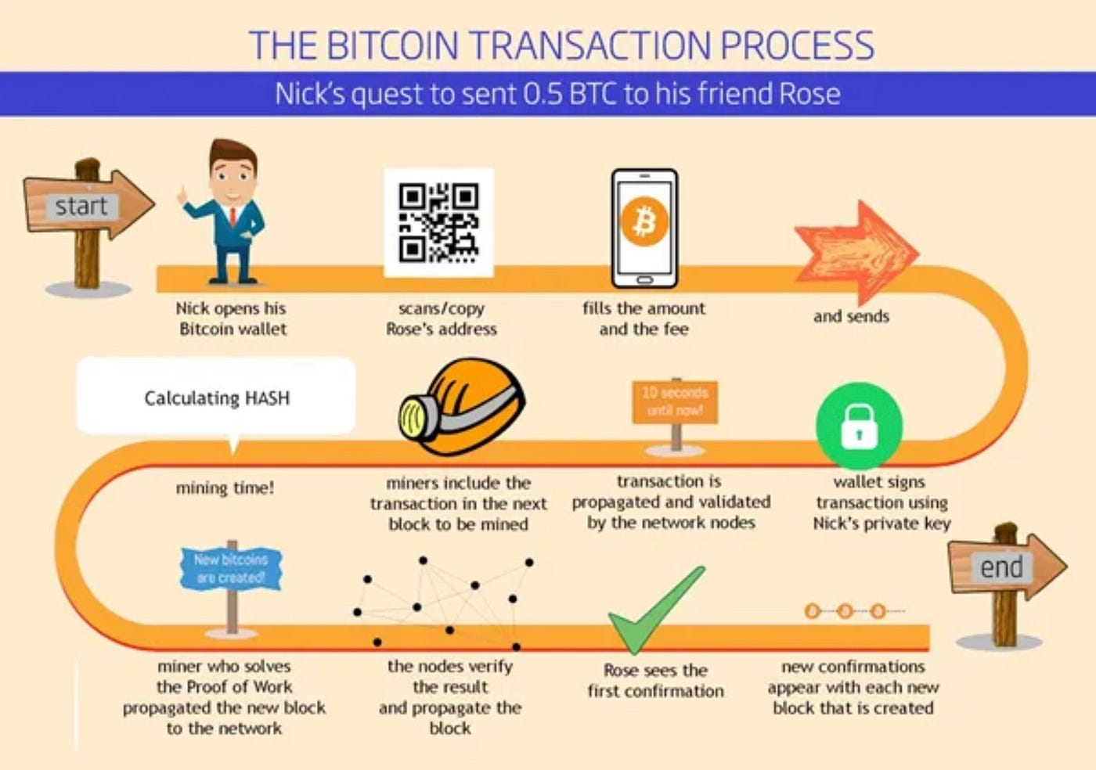

- Applications of Blockchain Technology
Blockchain technology is not just limited to cryptocurrencies like Bitcoin; it has the potential to revolutionize many industries by providing secure, transparent, and decentralized solutions. Below are some of the key applications of blockchain technology:

1. Cryptocurrency and Digital Payments
- Bitcoin, Ethereum, and Other Cryptocurrencies: The most popular application of blockchain is in the creation of digital currencies. Cryptocurrencies use blockchain to enable secure, peer-to-peer transactions without the need for a central authority, such as a bank or government. They allow for quick, low-cost cross-border payments.
- Stable coins: These are cryptocurrencies pegged to a stable asset like the U.S. dollar, and they are used for everyday transactions, remittances, and hedging against market volatility.
- Cross-border Payments: Blockchain allows for faster, cheaper, and more secure cross-border transactions by removing the need for intermediaries like banks or payment processors.

2. Supply Chain Management
- Tracking Goods and Ensuring Transparency: Blockchain can be used to track products as they move through the supply chain, ensuring transparency and traceability. For example, in food supply chains, blockchain can be used to track the origin and journey of food products, ensuring quality and safety standards are met.
- Counterfeit Prevention: In industries like luxury goods, pharmaceuticals, and electronics, blockchain helps prove the authenticity of products by tracking their origin, making it more difficult for counterfeit products to enter the market.

3. Healthcare
- Secure Patient Data: Blockchain can provide a secure, decentralized platform for storing and sharing electronic health records (EHR). Patients can control access to their health data and share it seamlessly with medical providers, ensuring privacy and security.
- Drug Traceability: Blockchain can be used to track the journey of pharmaceutical drugs from manufacturing to distribution, ensuring the authenticity and quality of medicines and preventing counterfeit drugs.
- Clinical Trials: Blockchain can make clinical trials more transparent by recording all stages of the trial process, including patient consent, data collection, and results, preventing data tampering.

4. Voting Systems
- Electronic Voting: Blockchain can be used to create secure, tamper-proof voting systems. By using blockchain, each vote can be securely recorded on the blockchain, making it transparent and easily auditable, ensuring the integrity of the election process.
- Verifiable Election Results: Blockchain’s immutable ledger allows for transparent and tamper-proof election results, reducing the risk of fraud and increasing public trust in the election process.

5. Smart Contracts
- Automating Agreements: Smart contracts are self-executing contracts where the terms of the agreement are written into code. These contracts automatically execute actions when predefined conditions are met, eliminating the need for intermediaries, reducing costs, and speeding up processes.
- Examples: In real estate, smart contracts can automatically transfer ownership of a property once the payment is made. In insurance, smart contracts can automatically trigger payouts when certain conditions are met (e.g., a flight delay).

6. Decentralized Finance (Defi)
- Banking Without Intermediaries: Defi platforms use blockchain technology to recreate traditional financial services like lending, borrowing, trading, and saving, but without banks or other intermediaries. These platforms use smart contracts to automate and enforce agreements.
- Decentralized Exchanges (DEX): Blockchain enables decentralized exchanges where users can trade cryptocurrencies directly with each other without needing a centralized authority or exchange.
- Yield Farming and Staking: Blockchain allows users to lend their cryptocurrencies or participate in liquidity pools, earning rewards (interest or tokens) in return for providing liquidity to decentralized platforms.

7. Identity Management and Authentication
- Digital Identity: Blockchain can be used to create secure and verifiable digital identities. Individuals can own their identities and control who has access to their personal information. This reduces the risks of identity theft and fraud.
- Self-sovereign Identity (SSI): Blockchain can be used to give individuals control over their identity by allowing them to manage and share their personal data (e.g., government IDs, medical records) without relying on central authorities.

8. Intellectual Property Protection
- Copyright and Ownership Tracking: Blockchain can be used to register intellectual property (e.g., music, art, patents), allowing creators to prove ownership and track how their work is used or distributed. This reduces copyright infringement and ensures creators are properly compensated.
- Music and Digital Media: Blockchain can enable creators to sell their work directly to consumers and receive a fair share of the revenue, eliminating intermediaries like music labels or streaming platforms.

9. Insurance
- Automated Claims Processing: Blockchain can streamline the insurance industry by using smart contracts to automatically process claims. For example, if a flight is delayed, a smart contract can automatically trigger a payout to the policyholder.
- Transparent Policies: Blockchain’s transparency allows policyholders and insurers to verify the terms of policies, claims, and payments in real time, reducing fraud and increasing trust.

10. Real Estate
- Property Transactions: Blockchain can simplify property transactions by automating processes such as property title transfers, verification, and payments using smart contracts. This reduces paperwork, time delays, and the need for intermediaries (e.g., real estate agents and notaries).
- Tokenization of Assets: Real estate can be tokenized, allowing ownership to be divided into smaller, tradable units. This lowers the barrier to entry for real estate investment, as people can invest in fractions of properties rather than needing to buy whole properties.

11. Energy Sector
- Decentralized Energy Trading: Blockchain can facilitate peer-to-peer energy trading, where individuals or businesses can trade renewable energy with each other. Smart contracts can automate energy exchanges between producers and consumers, making the energy grid more efficient.
- Tracking Energy Production: Blockchain can track the production and consumption of renewable energy, ensuring that it is sourced responsibly and allowing consumers to verify that they are purchasing green energy.

12. Supply Chain Finance
- Invoice Financing: Blockchain can be used to digitize and securely store invoices, allowing businesses to access financing by using their invoices as collateral. This can streamline the process of obtaining loans or credit, especially for small businesses.
- Trade Finance: Blockchain can simplify cross-border trade by automating and securing the processes involved in trade finance, such as letters of credit and documentary collections, reducing paperwork, fraud, and delays.

13. Gaming
- In-Game Assets and NFTs: Blockchain allows players to truly own their in-game assets (e.g., skins, weapons, characters) through Non-Fungible Tokens (NFTs). Players can trade, sell, or buy assets across games or platforms without relying on a centralized server or authority.
- Decentralized Gaming Platforms: Blockchain enables decentralized gaming ecosystems where developers and players interact directly, and the game’s rules or rewards are managed through smart contracts.

14. Charity and Philanthropy
- Transparent Donations: Blockchain can increase transparency in charitable donations, allowing donors to track exactly where their money goes and ensuring that it is used for its intended purpose.
- Smart Contracts for Fund Distribution: Charities can use smart contracts to automate the distribution of funds based on certain criteria, such as meeting specific goals or milestones in a project.

15. Legal and Notary Services
- Smart Legal Contracts: Blockchain can enable the creation of legally binding smart contracts that automatically execute when certain conditions are met, reducing the need for intermediaries in contract enforcement.
- Digital Notarization: Blockchain can provide a secure and immutable system for notarizing documents, verifying their authenticity, and recording their history in a transparent and tamper-proof manner.

Conclusion
Blockchain technology has vast potential and is being applied across a variety of industries to enhance transparency, reduce fraud, increase efficiency, and provide new ways of doing business. Its decentralized nature and ability to securely store and share data have made it a game-changing innovation in areas ranging from finance and healthcare to supply chain management, voting systems, and beyond. As blockchain adoption continues to grow, we can expect to see even more creative applications emerge in the coming years.
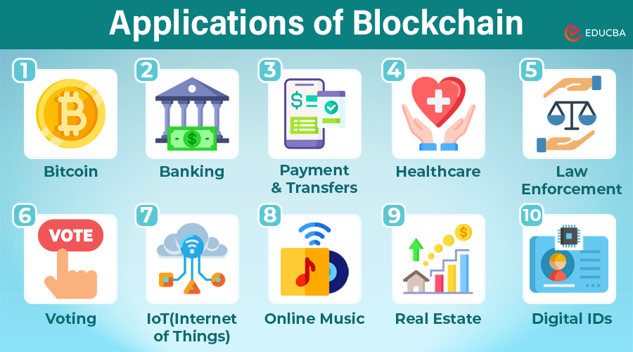

- Advantages of Blockchain Technology
Blockchain technology offers several distinct advantages that make it an appealing solution for a wide range of industries and use cases. These benefits stem from its decentralized, transparent, and secure nature. Here are the key advantages of blockchain technology:

1. Decentralization
- No Central Authority: One of the primary advantages of blockchain is that it eliminates the need for a central authority or intermediary (like a bank or government). In traditional systems, transactions and data are often controlled by central institutions. Blockchain distributes this power across a network of nodes, making it decentralized. This means no single party can control the data, reducing the risk of censorship and centralized manipulation.
- Peer-to-Peer Transactions: Blockchain allows individuals or organizations to directly transact with each other in a peer-to-peer (P2P) manner, removing the need for intermediaries.

2. Transparency
- Immutable Ledger: Once a transaction is recorded on the blockchain, it becomes nearly impossible to alter or delete. This immutability ensures that the data stored on the blockchain is transparent and traceable, making it easier to audit and verify.
- Visibility: All participants in the blockchain network can access and verify the transaction history, which promotes trust and reduces the risk of fraud. For example, in supply chain management, blockchain can ensure the transparency of each step in the process.

3. Security
- Cryptographic Security: Blockchain uses advanced cryptographic techniques to secure data. Each block is linked to the previous one using a cryptographic hash, making it nearly impossible to alter past transactions without being detected. Additionally, transactions are verified using consensus algorithms (e.g., Proof of Work, Proof of Stake), which prevent unauthorized changes.
- Data Integrity: Blockchain ensures that once a piece of data is added to the chain, it is immutable and cannot be tampered with, preserving the integrity of the data stored on the network.
- Reduced Risk of Fraud: Since blockchain is decentralized, there is no single point of failure or target for cyberattacks, making it harder for malicious actors to manipulate the system.

4. Efficiency and Speed
- Faster Transactions: Traditional systems, such as banks, may take several hours or even days to process certain transactions, especially cross-border payments. Blockchain allows for near-instantaneous transactions, with some blockchains settling transactions in minutes, regardless of geographical locations.
- Automation through Smart Contracts: Smart contracts, which are self-executing contracts with predefined conditions coded into them, can automate complex processes without the need for intermediaries. This reduces administrative overhead and speeds up transactions and business operations.

5. Cost Savings
- Reduced Intermediaries: By eliminating intermediaries such as banks, notaries, or third-party services, blockchain reduces transaction fees and other administrative costs. This can be particularly beneficial in industries like finance, real estate, and insurance.
- Lower Operational Costs: Blockchain eliminates the need for traditional record-keeping systems and manual processes, saving businesses money in terms of personnel, paperwork, and administrative overhead.

6. Traceability
- Audit Trails: Blockchain provides a complete and verifiable history of transactions, which makes it particularly useful in industries where traceability is crucial, such as supply chain management and food safety. For example, every stage of the production and distribution process can be recorded on the blockchain, making it easier to track the origin of products and verify their authenticity.
- Prevention of Fraud and Counterfeiting: By recording every transaction on an immutable ledger, blockchain can help prevent fraud, counterfeiting, and other illicit activities. In industries like pharmaceuticals or luxury goods, blockchain helps verify the authenticity and provenance of products.

7. Resilience and Availability
- Distributed Network: Because blockchain operates on a decentralized network of nodes, it is highly resistant to attacks or technical failures. If one node goes offline or is compromised, the other nodes can continue to operate normally, ensuring that the system remains functional and secure.
- No Single Point of Failure: In traditional centralized systems, a failure in a single server or database can cause disruptions. Blockchain, with its distributed nature, ensures that there is no single point of failure, enhancing the overall resilience and reliability of the system.

8. Global Accessibility
- Borderless Transactions: Blockchain is not limited by geographic location or regulatory boundaries. It allows for fast, low-cost transactions across borders, which is particularly useful for global financial systems and remittances.
- Access for the Unbanked: In many regions, traditional banking infrastructure may not be readily available. Blockchain can provide an alternative means of transacting, particularly in the form of cryptocurrencies, enabling access to financial services for people who are unbanked or underbanked.

9. Data Privacy
- Control Over Personal Data: Blockchain allows users to have more control over their personal data. With the use of public and private keys, individuals can manage and control access to their data, ensuring greater privacy compared to traditional systems where centralized entities control and store personal information.
- Anonymity Options: Some blockchain systems, such as Monero and Zcash, are designed with enhanced privacy features that allow for anonymous transactions, providing an additional layer of security for users concerned about privacy.

10. Innovation and New Business Models
- Decentralized Applications (dApps): Blockchain allows developers to create decentralized applications (dApps), which run on blockchain platforms like Ethereum. These applications eliminate the need for central servers and intermediaries, creating new opportunities for innovation and business models.
- Tokenization: Blockchain enables the tokenization of assets, allowing for the creation of digital representations of real-world assets such as real estate, art, and commodities. This opens up new markets and investment opportunities, including fractional ownership.

11. Environmental Sustainability
- Proof of Stake (PoS) and Energy Efficiency: While traditional blockchain networks like Bitcoin use energy-intensive Proof of Work (PoW), newer consensus mechanisms like Proof of Stake (PoS) consume significantly less energy. This makes blockchain more sustainable and less harmful to the environment.
- Green Technologies: Blockchain is also being explored for use in managing carbon credits, renewable energy trading, and creating sustainable supply chains, contributing to a more environmentally-friendly future.

Conclusion
Blockchain technology offers numerous advantages that make it a powerful tool for transforming industries and business operations. Its decentralized, secure, and transparent nature enables faster, more efficient transactions, cost savings, and enhanced trust. As the technology continues to mature, these advantages will likely expand, leading to new opportunities for innovation and economic growth across a wide range of sectors.

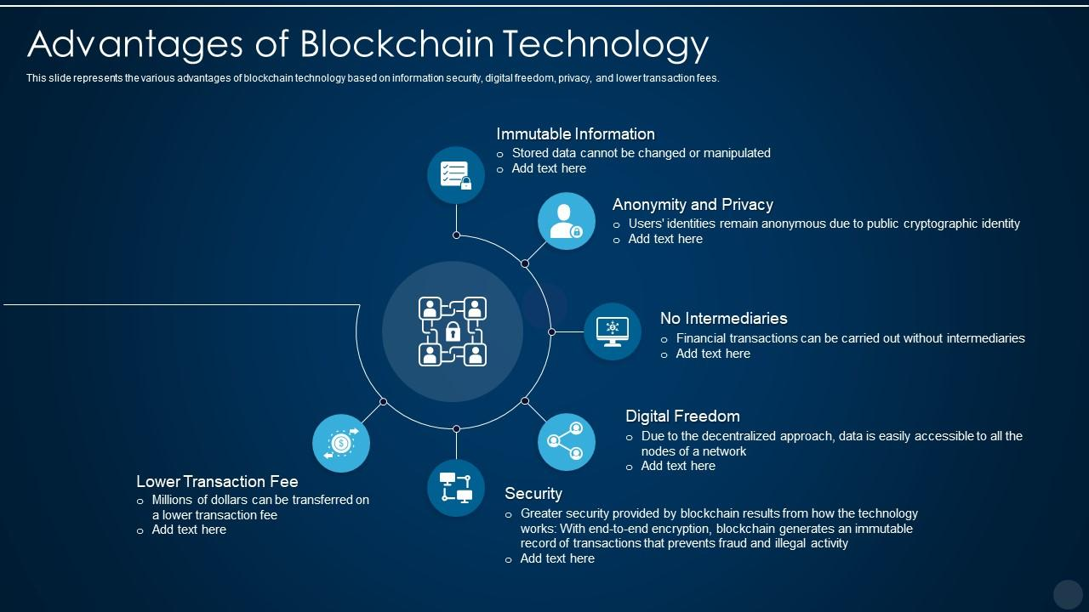
- Disadvantages of Blockchain Technology
While blockchain technology offers numerous advantages, it also comes with certain disadvantages that need to be considered when implementing it in various applications. Below are some of the main disadvantages of blockchain technology:

1. Scalability Issues
- Limited Transaction Speed: One of the major challenges of blockchain is its ability to handle a large number of transactions quickly. Public blockchains like Bitcoin and Ethereum often face issues with scalability, as they can only process a limited number of transactions per second (TPS). Bitcoin, for instance, can handle about 7 transactions per second, which is significantly lower than traditional payment systems like Visa, which can handle thousands of transactions per second.
- Network Congestion: As more users join a blockchain network, the system can become congested, leading to delays and higher transaction costs. This issue becomes more apparent in periods of high demand, making blockchain less efficient for high-frequency transaction applications.

2. Energy Consumption (for Proof of Work)
- High Energy Usage: Blockchain networks using Proof of Work (PoW), like Bitcoin, require significant amounts of computational power and energy to validate transactions and secure the network. Mining, which involves solving complex cryptographic puzzles, consumes large amounts of electricity, contributing to environmental concerns.
- Environmental Impact: The energy consumption of PoW networks has drawn criticism due to the environmental impact, especially if the electricity is generated from non-renewable sources. This has led to increased scrutiny regarding the sustainability of such blockchain systems.

3. Storage Concerns
- Growing Data Size: As more transactions are added to the blockchain, the size of the blockchain ledger increases. This results in large storage requirements for each node in the network, as they must store the entire history of transactions. This can make it difficult for individuals or smaller organizations to run a full node, limiting decentralization.
- Data Bloat: Over time, the blockchain's data size can become burdensome, and the larger the blockchain grows, the more difficult it becomes to manage. In some cases, full nodes may require hundreds of gigabytes of storage, which might not be feasible for some users or organizations.

4. Regulatory Uncertainty
- Lack of Regulation: Blockchain, particularly cryptocurrency-related applications, is still in its early stages, and governments around the world are grappling with how to regulate the technology. The lack of clear regulatory guidelines can create uncertainty, making it challenging for businesses and individuals to adopt blockchain in certain regions or sectors.
- Legal Ambiguities: As blockchain operates in a decentralized manner, it can sometimes create challenges in terms of liability and governance. For example, identifying the responsible parties in case of fraud, hacks, or mistakes on a decentralized blockchain can be difficult.
- Cross-Border Issues: Because blockchain transactions often transcend national borders, issues arise with regard to jurisdiction and compliance with local laws, especially in areas like taxation, money laundering, and anti-terrorism regulations.

5. Complexity
- Technical Expertise Required: Implementing and maintaining a blockchain solution requires specialized knowledge of the underlying technology, cryptography, and software development. Many organizations struggle to find professionals with the necessary expertise to create, manage, and integrate blockchain systems effectively.
- User Adoption: Blockchain technology, particularly in the form of cryptocurrency wallets and decentralized applications (dApps), can be difficult for non-technical users to adopt. For instance, managing private keys, understanding wallet setups, and troubleshooting errors can be confusing for users who are not familiar with blockchain concepts.

6. Irreversibility of Transactions
- No Undoing Transactions: Once a transaction is recorded on a blockchain, it cannot be reversed or modified. While this is generally an advantage for security and transparency, it can be problematic in cases where mistakes are made or transactions are fraudulent. There is no mechanism to cancel or reverse a transaction, which can be a disadvantage in certain use cases.
- Human Error: In scenarios like cryptocurrency transactions, users may accidentally send funds to the wrong address or make mistakes during the process. Since blockchain transactions are irreversible, such errors can result in a permanent loss of funds.

7. Privacy Concerns
- Public Ledger Visibility: Blockchain transactions are often visible to all participants in the network, and while they can be pseudonymous, they can still expose sensitive information, such as transaction amounts and addresses. In public blockchains like Bitcoin, anyone can trace transactions on the network and analyze user activity, potentially compromising privacy.

8. Risk of 51% Attacks (in Public Blockchains)
- Centralization Risk: In a Proof of Work (PoW) blockchain, if a single entity or group controls more than 50% of the mining power (a situation known as a 51% attack), they can potentially manipulate the blockchain by reversing transactions, double-spending coins, or blocking other users' transactions.
- While 51% attacks are rare and difficult to achieve in large networks, they are still a potential vulnerability in smaller or less secure blockchain networks.

9. Transaction Costs
- High Fees in Popular Networks: As blockchain networks become more congested, transaction fees can increase significantly. For example, Ethereum gas fees can spike during periods of high demand, making transactions costly. While blockchain aims to reduce transaction costs by eliminating intermediaries, high fees can still exist, especially in public blockchain networks.
- Cost of Scaling: Scaling blockchain to handle higher transaction volumes often requires the implementation of additional infrastructure, which can incur significant costs in terms of computational power and resources

10. Lack of Standardization
- Fragmented Ecosystem: The blockchain space is still fragmented, with various platforms, consensus mechanisms, and protocols in use. This lack of standardization makes it difficult for businesses to choose the right blockchain solution, and it can hinder interoperability between different blockchain networks.
- Compatibility Issues: As the technology evolves, compatibility between new and existing blockchain systems can be a challenge, especially in cases where different systems use different consensus mechanisms or block sizes.

11. Adoption Resistance
- Cultural and Institutional Resistance: Many industries, such as banking and government, have established infrastructure and processes that rely on centralized systems. Transitioning to blockchain-based systems may face resistance due to legacy systems, regulatory hurdles, and a lack of understanding or trust in the technology.
- Slow Adoption in Some Sectors: Despite its potential, blockchain adoption in certain sectors like healthcare, supply chain, and government is still relatively slow due to concerns about cost, complexity, and risk. Traditional organizations may be hesitant to switch to decentralized solutions due to the perceived risks involved.

Conclusion
While blockchain technology has transformative potential, it is not without its challenges. Issues related to scalability, energy consumption, complexity, and regulatory uncertainty remain significant barriers to its widespread adoption. Additionally, concerns about privacy, irreversibility of transactions, and the risk of attacks highlight the need for careful implementation and ongoing research to improve blockchain systems. Despite these disadvantages, many of these issues are being actively addressed through innovations in blockchain design, consensus mechanisms, and regulatory frameworks, making the technology more viable for future applications.
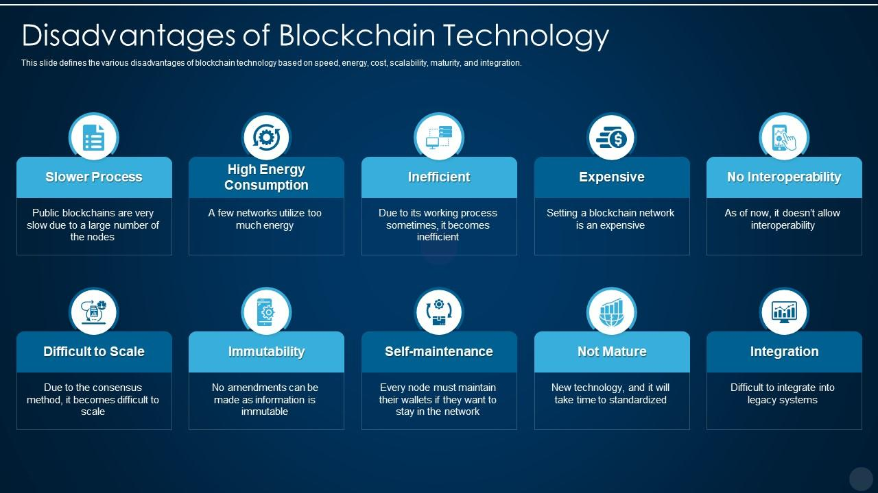
- Conclusion
Blockchain technology has the potential to revolutionize various industries by providing a secure, transparent, and decentralized system for recording and verifying transactions. It eliminates the need for intermediaries, enhances data security, and improves efficiency, all while ensuring that data is immutable and traceable. Blockchain’s ability to create trust in an environment where there is no central authority is one of its most powerful features.
However, blockchain is not without its challenges. Issues like scalability, high energy consumption (especially in proof-of-work models), regulatory uncertainty, and the complexity of implementation must be addressed before it can reach its full potential. Additionally, the technology’s reliance on large storage and computational power can create barriers for smaller organizations.
Despite these drawbacks, blockchain continues to evolve, with advancements in consensus mechanisms, such as Proof of Stake (PoS), and improvements in scalability and efficiency. As the technology matures, it is likely that we will see broader adoption across industries, especially in areas such as finance, supply chain management, healthcare, and government.
In conclusion, while blockchain presents exciting opportunities for innovation and transformation, it requires careful consideration of its challenges and a strategic approach to implementation. As the ecosystem matures and more solutions are developed, blockchain could become a foundational technology in the digital world, enabling more transparent, secure, and efficient systems globally.

- References

  - https://openai.com/index/chatgpt/
  - https://www.geeksforgeeks.org/blockchain-technology-introduction/
  - https://www.google.co.in/

